Measurement Stopper Work Instruction

Contents

Where can I reach the stopper file? 2

Where and how to place the stopper? 4

How to open the file? 5

How to use the timer? 7

How can I make daily Excel report? 10

Important Informations 12

How can I log if I have issue with the program? 12

# Where can I reach the stopper file?

1. 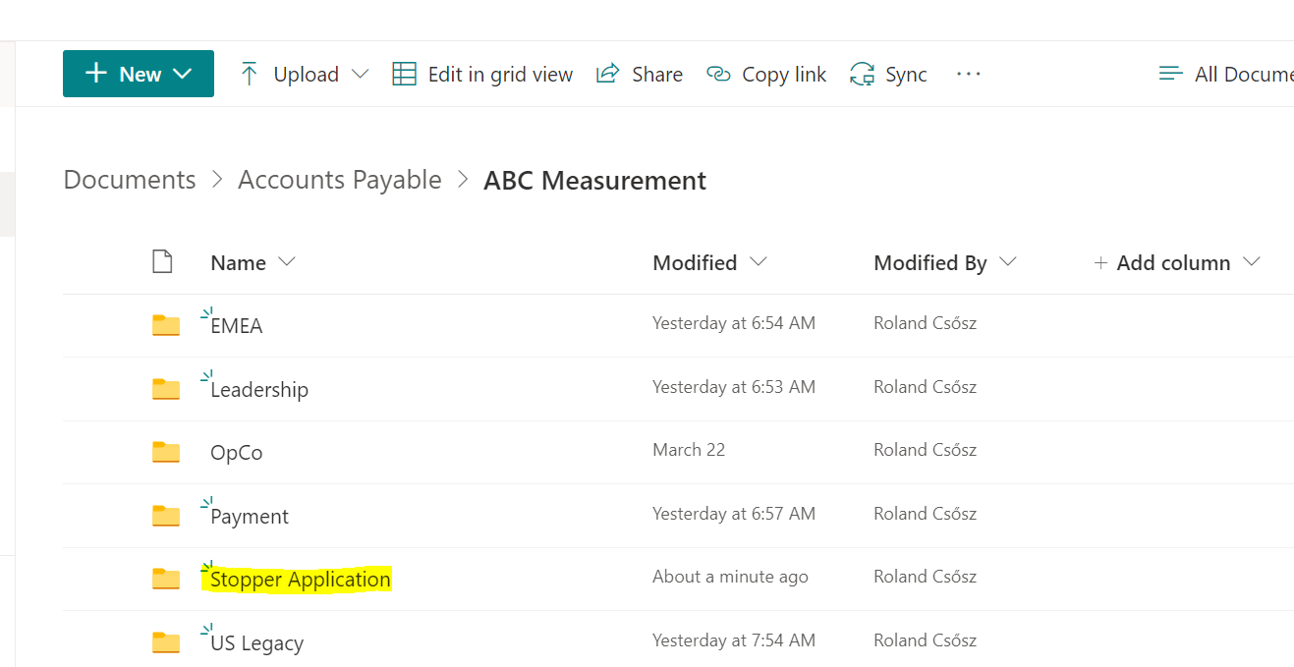On this [SharePoint link](https://albemarle01.sharepoint.com/sites/FS-BUD-AccountsPayable/Shared%20Documents/Forms/AllItems.aspx?viewid=90514dd0%2Dab98%2D4d15%2Daae2%2Dc4b41e8ab6e4&id=%2Fsites%2FFS%2DBUD%2DAccountsPayable%2FShared%20Documents%2FAccounts%20Payable%2FABC%20Measurement) you can reach this site.

1. After opening the Stopper Application you can find the file.

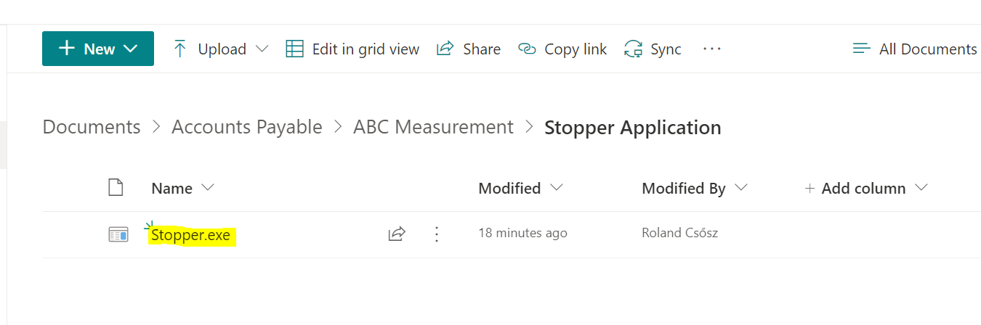

1. After opening the folder download the file to your local computer.

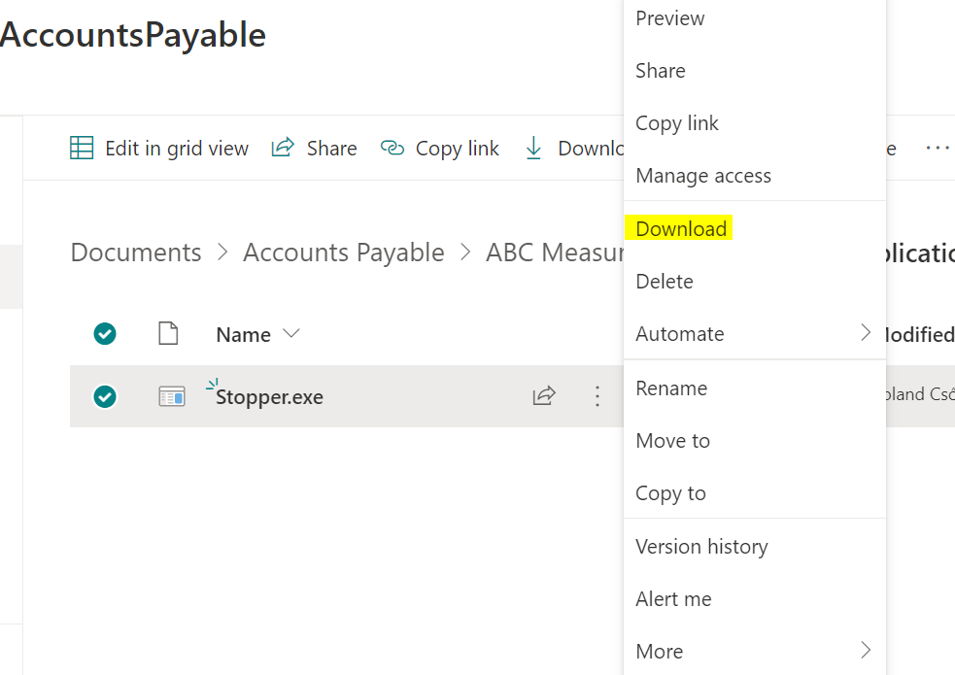

1. Or if you have synced Accounts Payable with your computer you can reach it in the file explorer: Albemarle/FS-BUD-AccountsPayable – Accouns Payable/ABC Measurement.

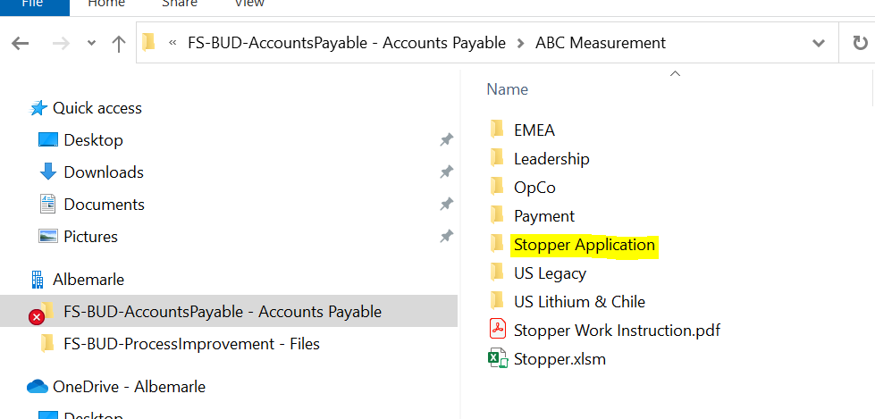

1. After opening the folder you can find the file.
2. Then make a copy to your computer by copy and paste it.
3. **PLEASE DO NOT USE THE ORIGINAL FILE IN THE FOLDER! Make a copy.**

# Where and how to place the stopper?

1. After downloading the stopper place it **from the Downloads** to the **Desktop** or to the **Documents** where you want to open it daily.
2. Make a folder with the name **Timer**
3. Place the Stopper.exe into this created folder
4. Then in the Timer folder create another folder with the name **Daily Reports**
5. After that you should see this.

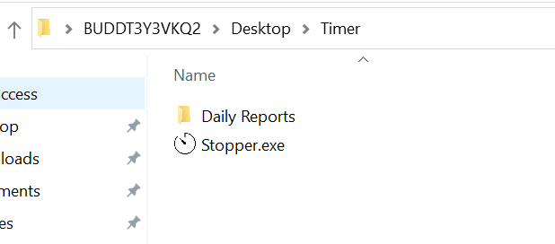

# How to open the file?

1. After you downloaded the file and located it on your computer open it.
2. You will see this windows first

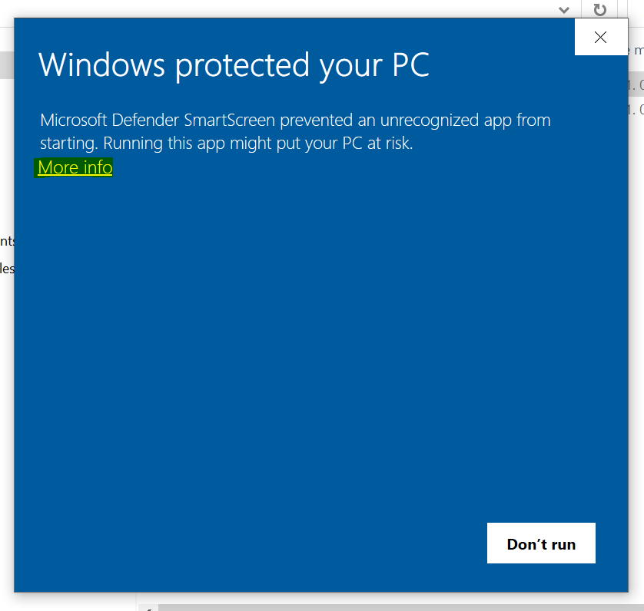

1. Click on the **More info.**

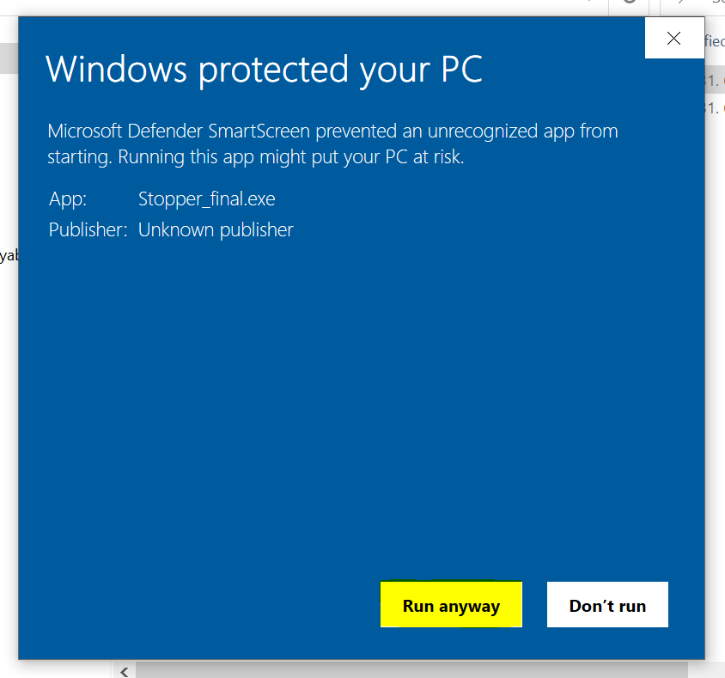

1. Click on Run Anyway.
2. After that you should be able to open the stopper
3. This windows will apear **in the first time**. After this the program **will be opened without asking**.

# How to use the timer?

1. 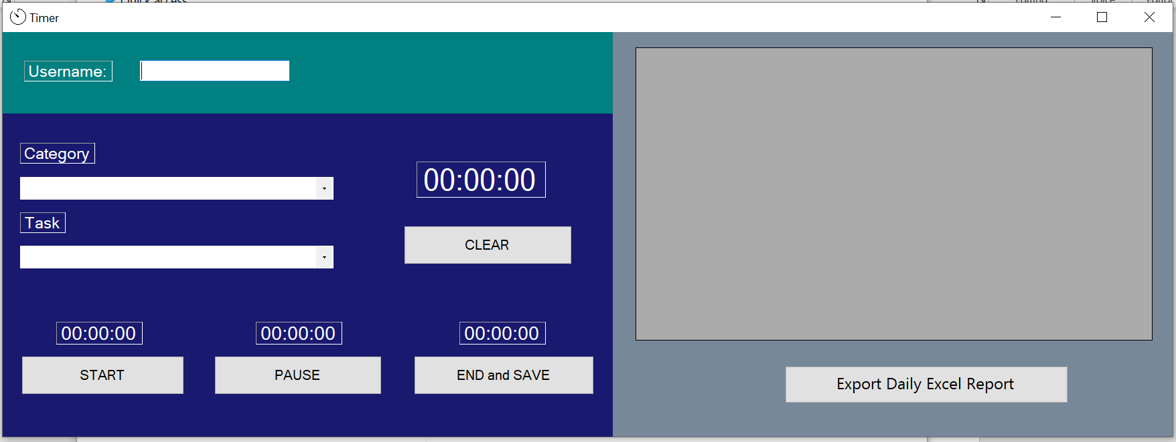After opening it you will see this.
2. **First write your name in the Username box**. This needed to be set in the first time. The next time the program will fill this box automaticly.
3. 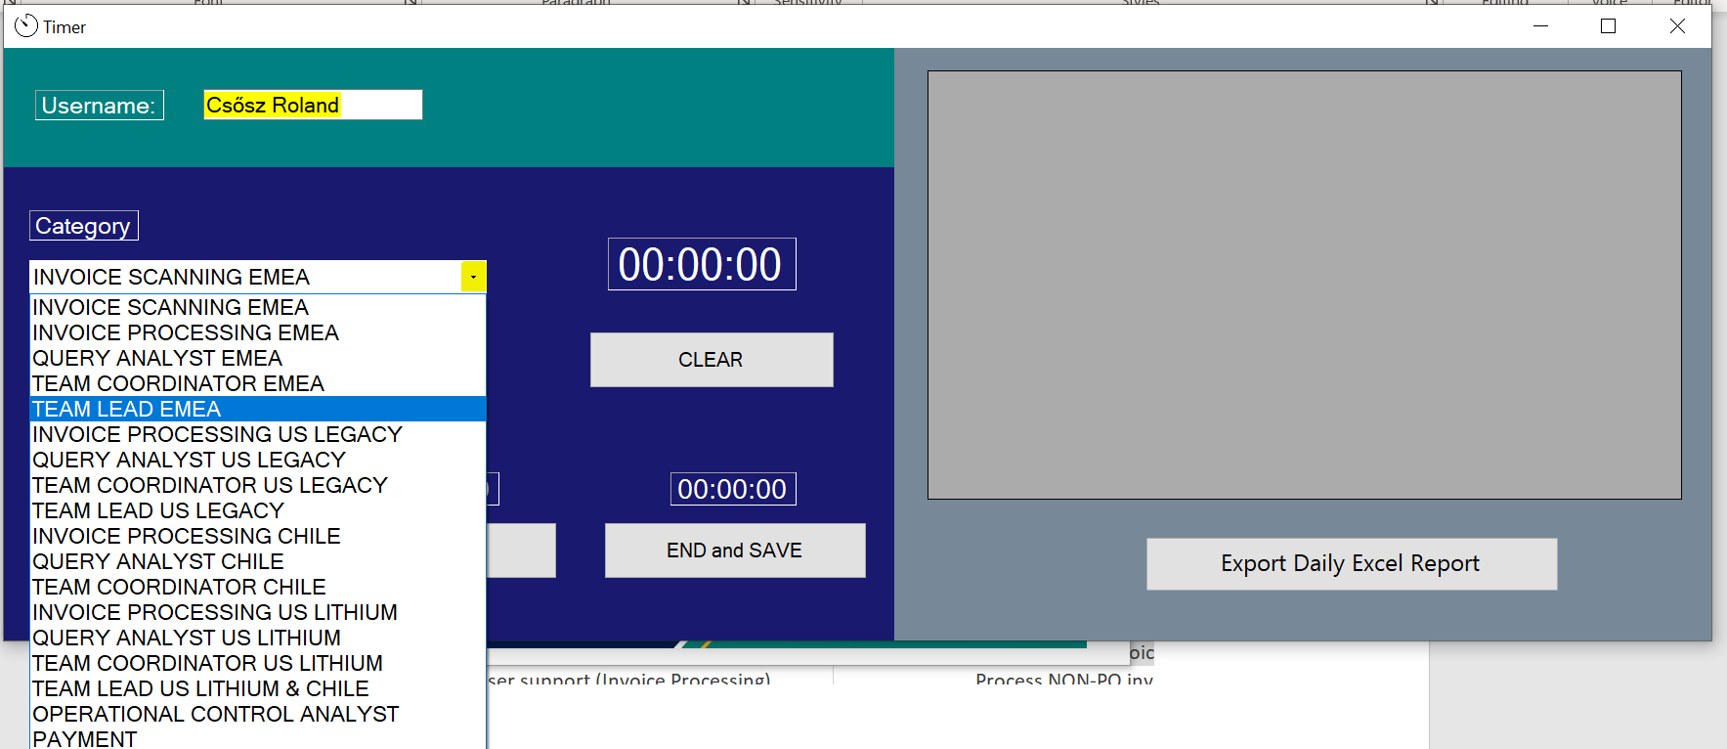After that select the category you want to measure and the task.
4. 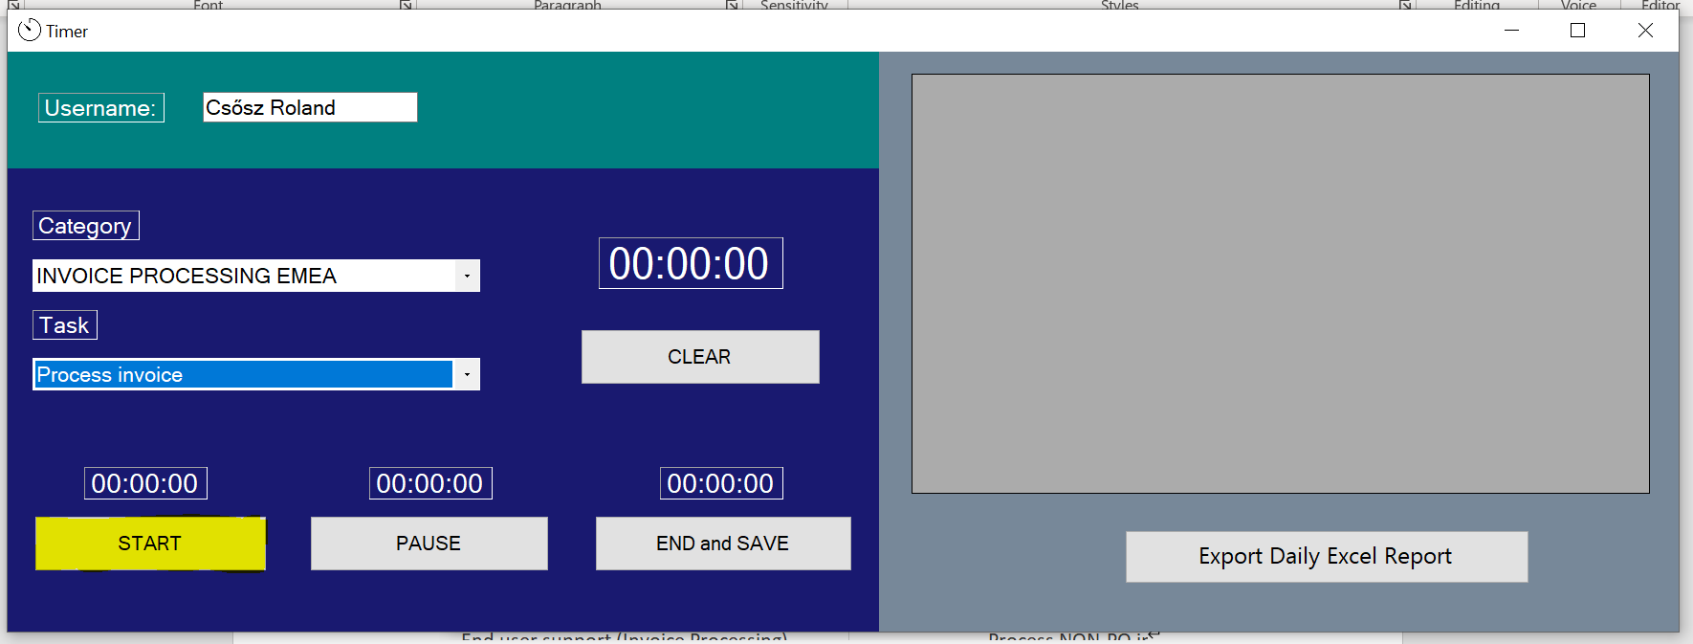After **you selected the Category**, the **Task** and you want to start to measure the task click on the START button.
5. To pause the procedure you can click on the PAUSE button several time.
6. If you **do not want to save the measured task** the click on the **CLEAR** button.
7. 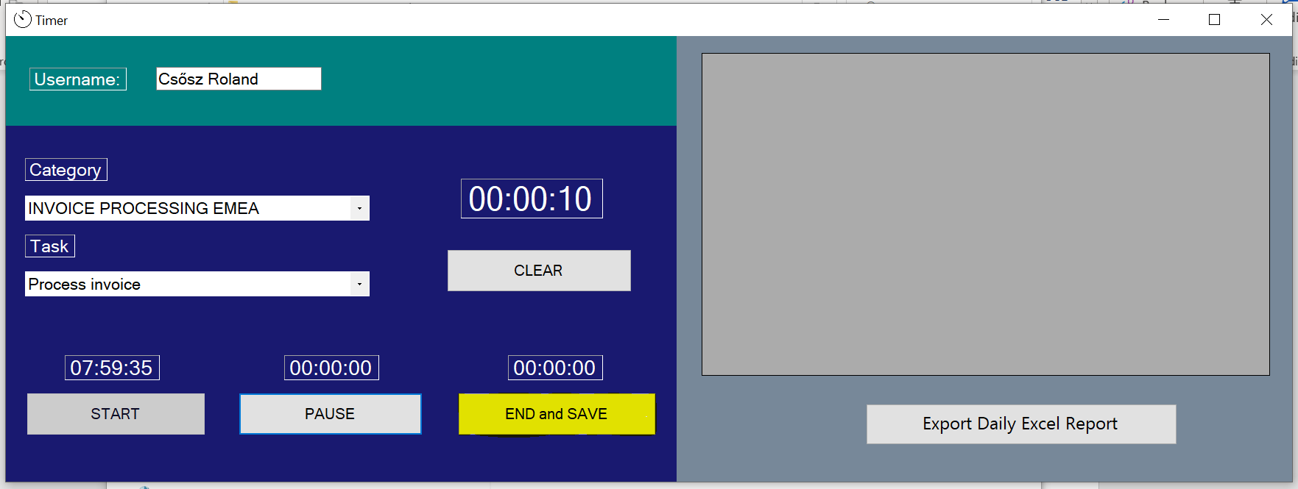To **finish the measuring and to save** the data click on the **END and SAVE** button.
8. After pressing END and SAVE you should see in the datagrid the saved task.

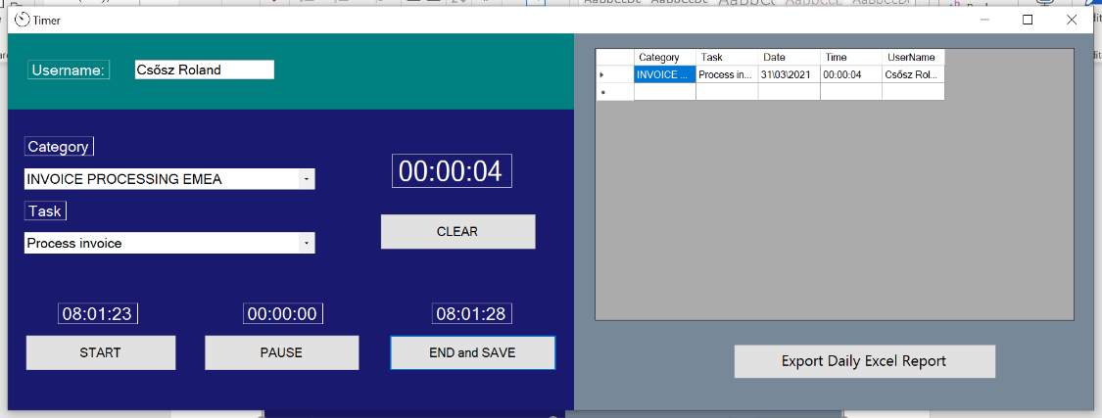

1. After The first use the program will generate two files in the folder. **PLEASE** **DO NOT DELETE OR MODIFY THESE FILES.**

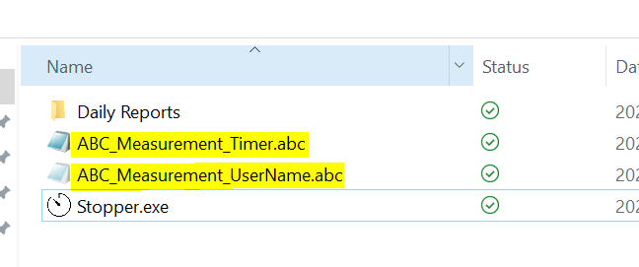

# How can I make daily Excel report?

1. First click on the Export Daily Excel Report button. This will export the data you measured on that day into an Excel file .

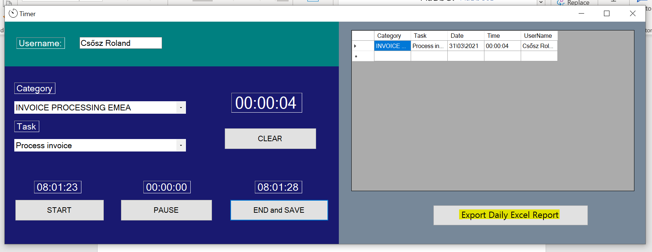

1. 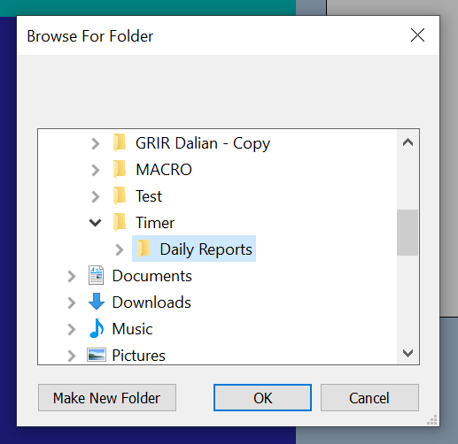Then select the Daily Reports in the folder of your stopper
2. Then click OK
3. After a while the report will apear in the selected folder with the date and the username in the name of the report.



1. After exporting the report you can try to open it but the file is locked by a password.
2. Upload the file to Daily Excel Reports SharePoint folder every day after you finished the measuring.

# Important Informations

1. If you do not select the category and the task the START button will not start the measuring.
2. The program generate/uses two file in the same foldar as the program. **DO NOT DELETE THEM!  
   They store the Username and the Measured Tasks.**

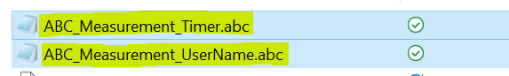

# How can I log issues with the program?

1. On this [SharePoint link](https://albemarle01.sharepoint.com/:f:/r/sites/FS-BUD-AccountsPayable/Shared%20Documents/Accounts%20Payable/ABC%20Measurement/Error%20Log?csf=1&web=1&e=GczuVd) You can reach the excel file where we collect the issues.
2. If you have any problem use the file and share any details/print screen.